

**SCHOOL OF COMPUTER SCIENCE ENGINEERING**

**AND INFORMATION SYSTEMS**

**WINTER SEMESTER 2024-2025**

**PMCA601P – FULL STACK WEB DEVELOPMENT LAB**

**PAT - 3**

**SUBMITTED ON: 04 - APR - 2025**

**SUBMITTED BY-**

**AKASH KUMAR BANIK**

**PROGRAM: MCA**

**REGISTER No.: 24MCA0242**

**1. Develop an Angular JS application that displays a list of shopping items. Allow users to add and remove items from the list using directives and controllers. Note: The default values of items may be included in the program.**

**CODE:**

**Index.html:**

<!DOCTYPE html>

<html ng-app="shoppingApp">

<head>

<meta charset="UTF-8">

<title>Shopping List</title>

<script src="https://ajax.googleapis.com/ajax/libs/angularjs/1.8.2/angular.min.js"></script>

<style>

body { font-family: Arial; margin: 30px; }

input, button { margin: 5px; }

ul { list-style-type: none; padding-left: 0; }

li { margin: 5px 0; }

button.remove-btn { margin-left: 10px; color: white; background-color: red; border: none; padding: 5px; }

</style>

</head>

<body ng-controller="ShoppingController">

<h1>Shopping List</h1>

<ul>

<li ng-repeat="item in items">

{{ item }}

<button class="remove-btn" ng-click="removeItem($index)">Remove</button>

</li>

</ul>

<input type="text" ng-model="newItem" placeholder="Enter item name">

<button ng-click="addItem()">Add Item</button>

<script>

var app = angular.module('shoppingApp', []);

app.controller('ShoppingController', function($scope) {

$scope.items = ['Milk', 'Bread', 'Eggs'];

$scope.addItem = function() {

if ($scope.newItem && $scope.items.indexOf($scope.newItem) === -1) {

$scope.items.push($scope.newItem);

$scope.newItem = '';

}

};

$scope.removeItem = function(index) {

$scope.items.splice(index, 1);

};

});

</script>

</body>

</html>

**OUTPUT:**

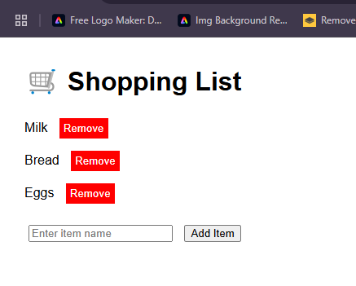

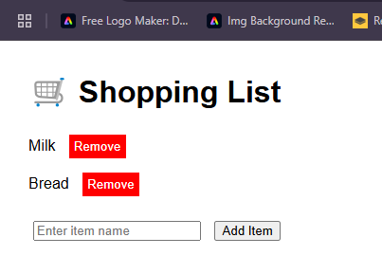

**2. Develop AngularJS application that displays a details of students and their CGPA. Allow users to read the number of students and display the count. Note: Student details may be included in the program.**

**CODE:**

**Index.html**

<!DOCTYPE html>

<html ng-app="studentApp">

<head>

<meta charset="UTF-8">

<title>Student CGPA List</title>

<script src="https://ajax.googleapis.com/ajax/libs/angularjs/1.8.2/angular.min.js"></script>

<style>

body { font-family: Arial; margin: 30px; }

table { border-collapse: collapse; width: 60%; }

th, td { border: 1px solid #ccc; padding: 8px; text-align: center; }

th { background-color: #f2f2f2; }

h2, p { margin: 10px 0; }

</style>

</head>

<body ng-controller="StudentController">

<h2>Student CGPA List</h2>

<table>

<thead>

<tr>

<th>Roll No</th>

<th>Name</th>

<th>CGPA</th>

</tr>

</thead>

<tbody>

<tr ng-repeat="student in students">

<td>{{ student.rollNo }}</td>

<td>{{ student.name }}</td>

<td>{{ student.cgpa }}</td>

</tr>

</tbody>

</table>

<p>Total Number of Students: <strong>{{ students.length }}</strong></p>

<script>

var app = angular.module('studentApp', []);

app.controller('StudentController', function($scope) {

$scope.students = [

{ rollNo: '101', name: 'Aarav Singh', cgpa: 8.7 },

{ rollNo: '102', name: 'Meera Patel', cgpa: 9.1 },

{ rollNo: '103', name: 'Karan Verma', cgpa: 7.9 },

{ rollNo: '104', name: 'Divya Rao', cgpa: 8.4 }

];

});

</script>

</body>

</html>

**OUTPUT:**

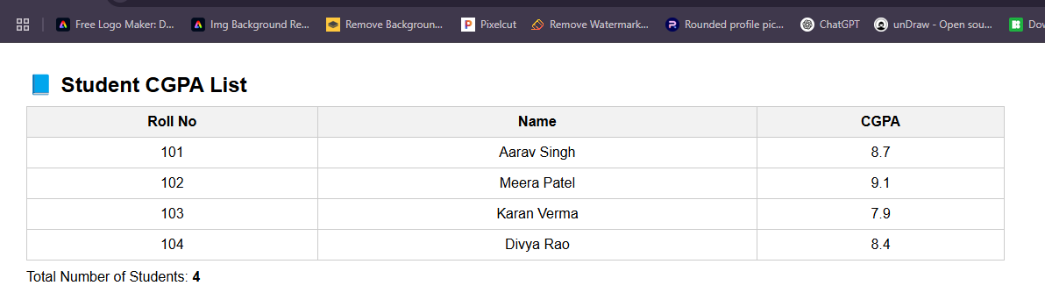

**3. Create an AngularJS application that displays a list of employees and their salaries. Allow users to search for employees by name and salary. Note: Employee details may be included in the program.**

**CODE:**

**Index.html:**

<!DOCTYPE html>

<html ng-app="employeeApp">

<head>

<meta charset="UTF-8">

<title>Employee Salary Search</title>

<script src="https://ajax.googleapis.com/ajax/libs/angularjs/1.8.2/angular.min.js"></script>

<style>

body { font-family: Arial; margin: 30px; }

table { border-collapse: collapse; width: 70%; margin-top: 15px; }

th, td { border: 1px solid #ccc; padding: 8px; text-align: center; }

th { background-color: #f2f2f2; }

input { margin-right: 10px; padding: 5px; }

</style>

</head>

<body ng-controller="EmployeeController">

<h2>Employee List with Salary Search</h2>

<div>

<input type="text" ng-model="searchName" placeholder="Search by Name">

<input type="number" ng-model="searchSalary" placeholder="Search by Salary">

</div>

<table>

<thead>

<tr>

<th>Emp ID</th>

<th>Name</th>

<th>Salary (₹)</th>

</tr>

</thead>

<tbody>

<tr ng-repeat="employee in employees | filter:filterByNameAndSalary">

<td>{{ employee.empId }}</td>

<td>{{ employee.name }}</td>

<td>{{ employee.salary }}</td>

</tr>

</tbody>

</table>

<script>

var app = angular.module('employeeApp', []);

app.controller('EmployeeController', function($scope) {

$scope.employees = [

{ empId: 'E101', name: 'Rahul Mehta', salary: 50000 },

{ empId: 'E102', name: 'Sneha Sharma', salary: 65000 },

{ empId: 'E103', name: 'Arjun Rao', salary: 60000 },

{ empId: 'E104', name: 'Pooja Iyer', salary: 55000 },

{ empId: 'E105', name: 'Ankit Verma', salary: 70000 }

];

$scope.filterByNameAndSalary = function(employee) {

var nameMatch = !$scope.searchName || employee.name.toLowerCase().includes($scope.searchName.toLowerCase());

var salaryMatch = !$scope.searchSalary || employee.salary == $scope.searchSalary;

return nameMatch && salaryMatch;

};

});

</script>

</body>

</html>

**OUTPUT:**

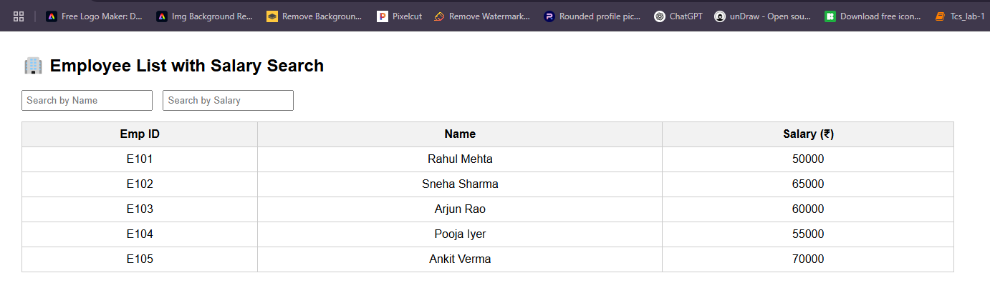

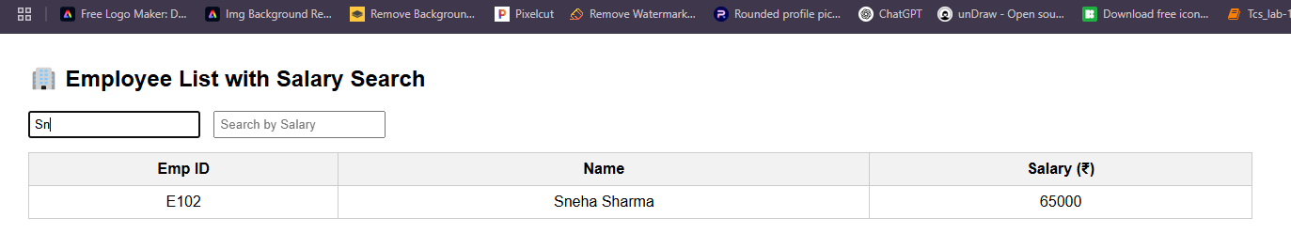

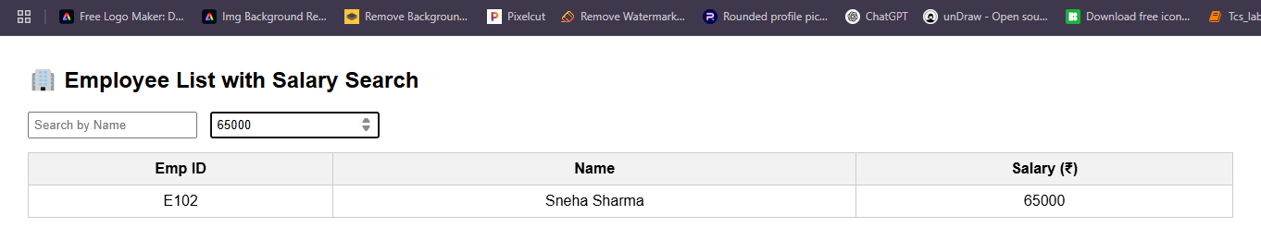

**4. Create AngularJS application that allows users to maintain a collection of items. The application should display the current total number of items, and this count should automatically update as items are added or removed. Users should be able to add items to the collection and remove them as needed. Note: The default values for items may be included in the program.**

**CODE:**

<!DOCTYPE html>

<html ng-app="itemApp">

<head>

<meta charset="UTF-8">

<title>Item Collection Manager</title>

<script src="https://ajax.googleapis.com/ajax/libs/angularjs/1.8.2/angular.min.js"></script>

<style>

body { font-family: Arial; margin: 30px; }

input, button { margin: 5px 0; padding: 6px; font-size: 14px; }

ul { margin-top: 15px; padding-left: 20px; }

li { margin-bottom: 5px; }

span { margin-right: 10px; }

</style>

</head>

<body ng-controller="ItemController">

<h2>Item Collection Manager</h2>

<p>Total Items: <strong>{{ items.length }}</strong></p>

<div>

<input type="text" ng-model="newItem" placeholder="Enter item name">

<button ng-click="addItem()">Add Item</button>

</div>

<ul>

<li ng-repeat="item in items track by $index">

<span>{{ item }}</span>

<button ng-click="removeItem($index)">Remove</button>

</li>

</ul>

<script>

var app = angular.module('itemApp', []);

app.controller('ItemController', function($scope) {

$scope.items = ['Pen', 'Notebook', 'Eraser', 'Pencil'];

$scope.addItem = function() {

if ($scope.newItem && $scope.newItem.trim() !== "") {

$scope.items.push($scope.newItem.trim());

$scope.newItem = "";

}

};

$scope.removeItem = function(index) {

$scope.items.splice(index, 1);

};

});

</script>

</body>

</html>

**OUTPUT:**

